Assignment 4 : Azure Cloud Fundamentals and Data Pipeline
Implementation using ADF
Step 1: Resource Group Creation
A Resource Group named RG-Superstore was created in Azure Portal. It serves as a logical container to organize and manage all resources related to the project, including Storage Account and Azure Data Factory.
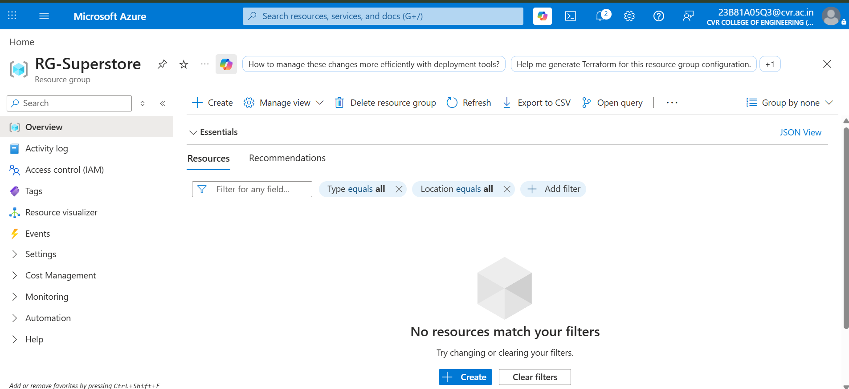

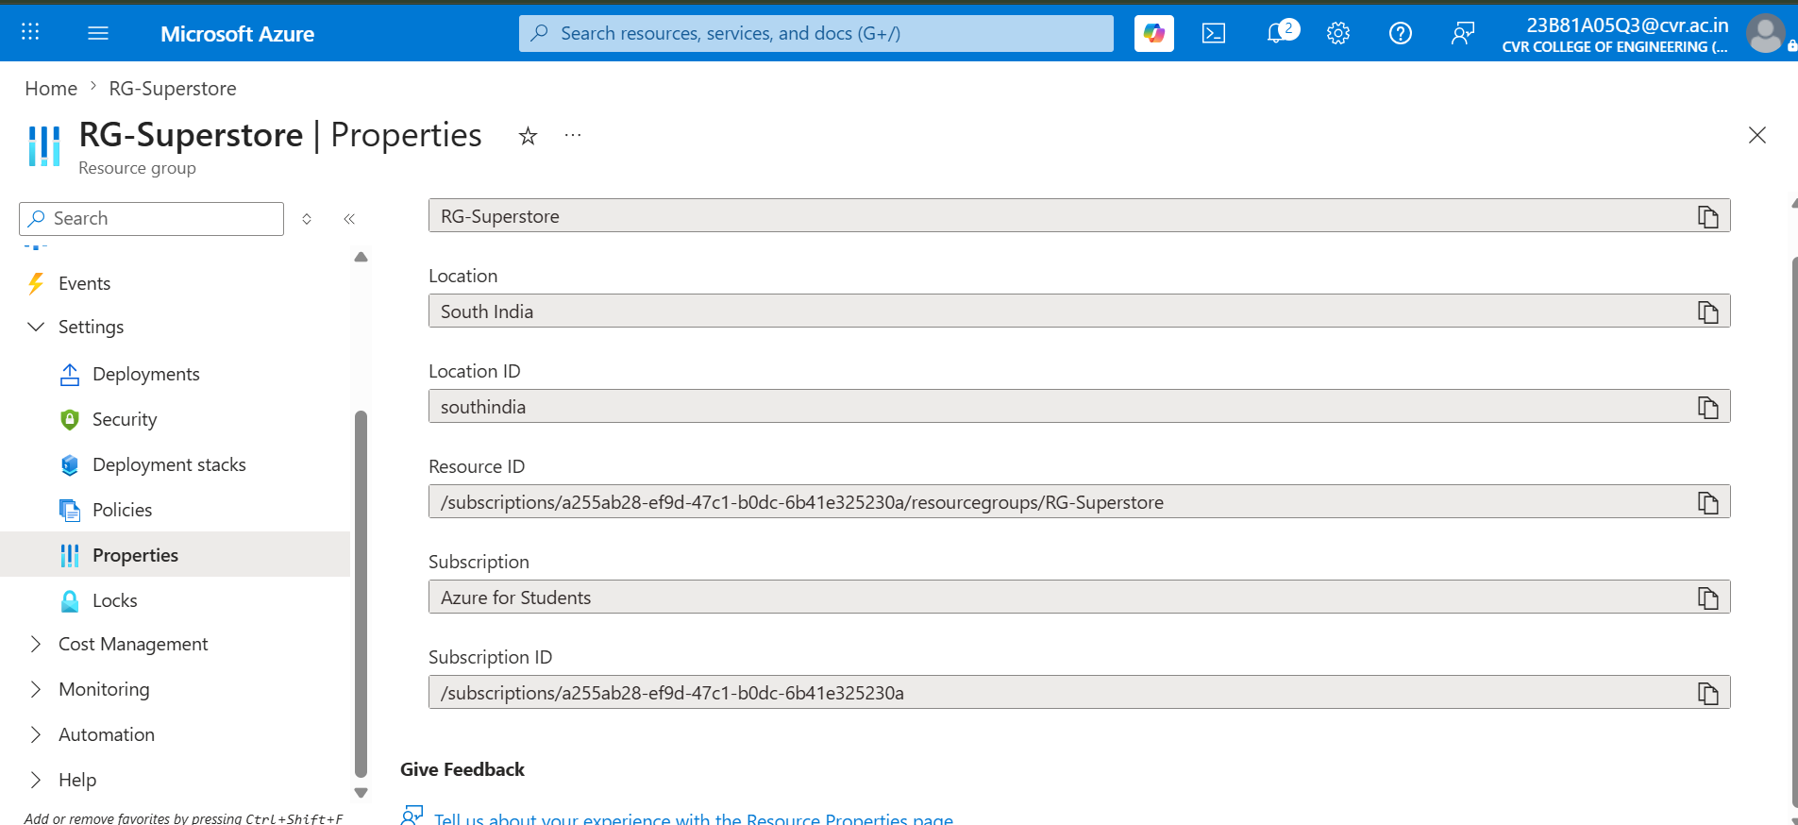

Step 2: Storage Account Creation
An Azure Storage Account was created to store the dataset and support data movement operations. The Storage Account provides scalable and secure cloud storage services.

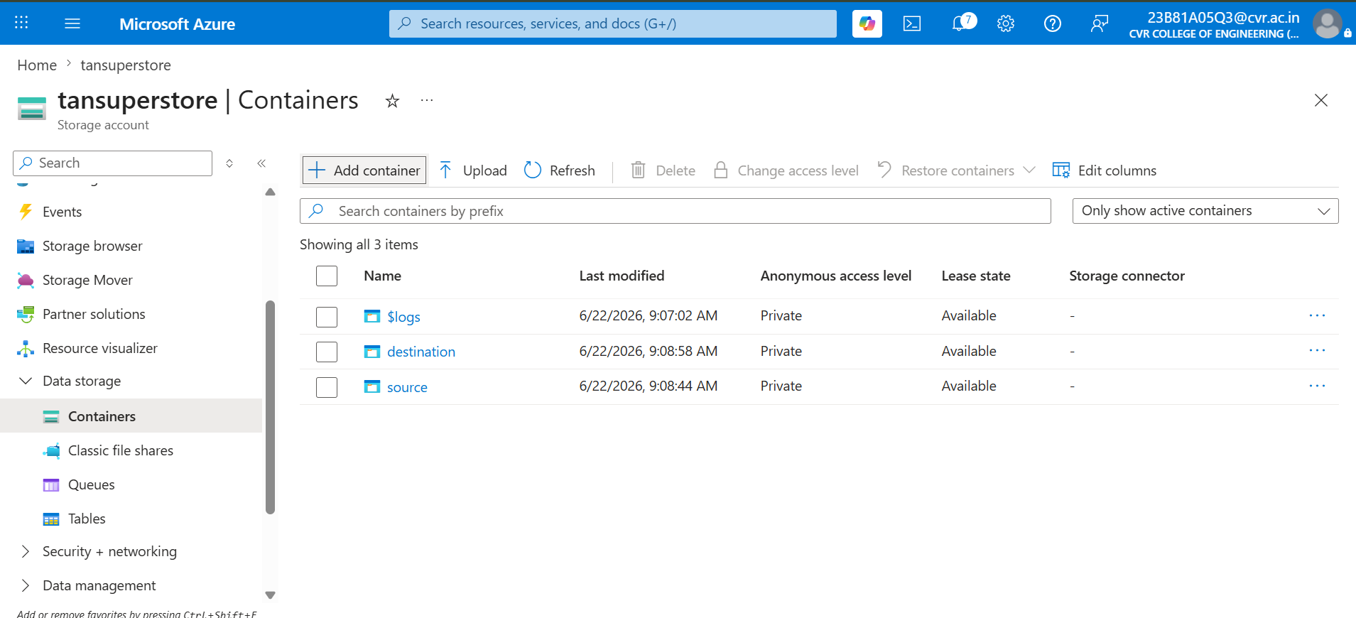
Step 3: Blob Container Creation
Two Blob containers were created:
- source-data – stores the original CSV file.
- destination-data – stores the copied output file after pipeline execution.
These containers act as the source and destination locations for the data pipeline.

Step 4: Dataset Upload
The Superstore CSV dataset was downloaded and uploaded to the source-data container. This file serves as the input for the Azure Data Factory pipeline.
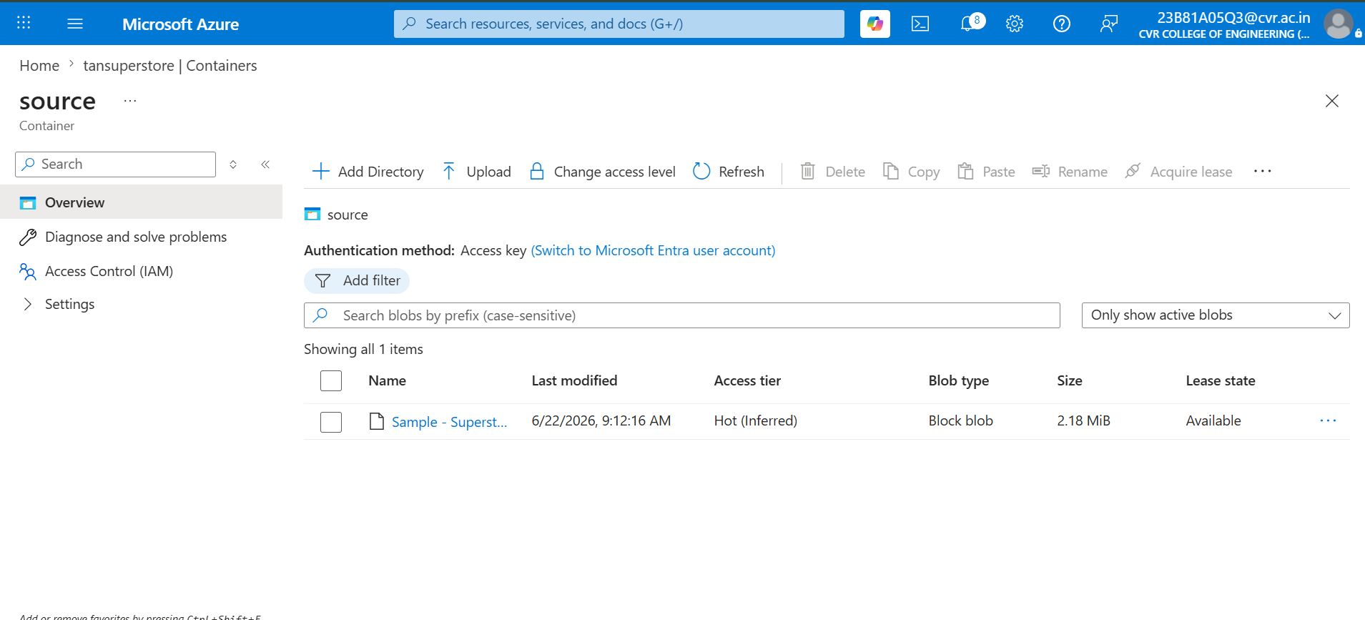
Step 5: Azure Data Factory Creation
An Azure Data Factory instance named tanADF-Superstore was created. ADF is a cloud-based data integration service used to build, schedule, and monitor data pipelines.
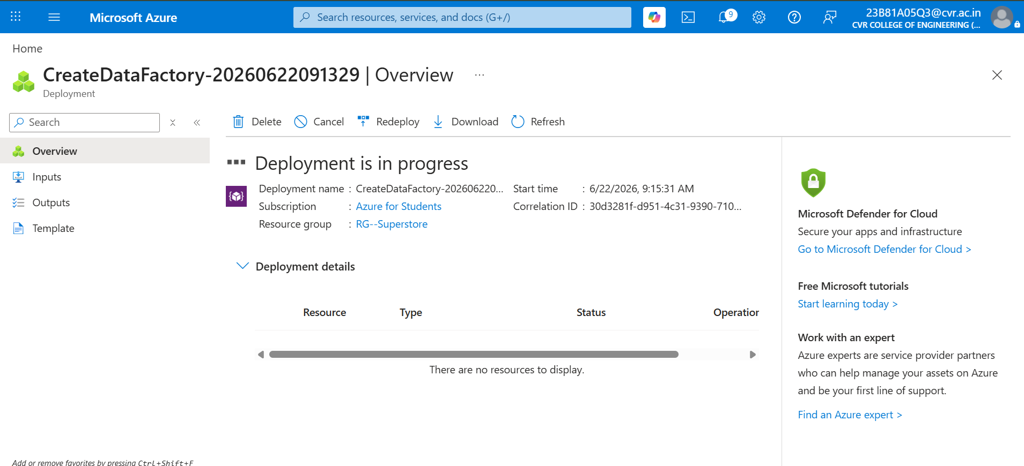

Step 6: Exploring Azure Data Factory
The Azure Data Factory Studio interface was explored:
- Author – Used for creating pipelines, datasets, and data flows.
- Monitor – Used for monitoring pipeline executions.
- Manage – Used for configuring linked services and access settings.
- 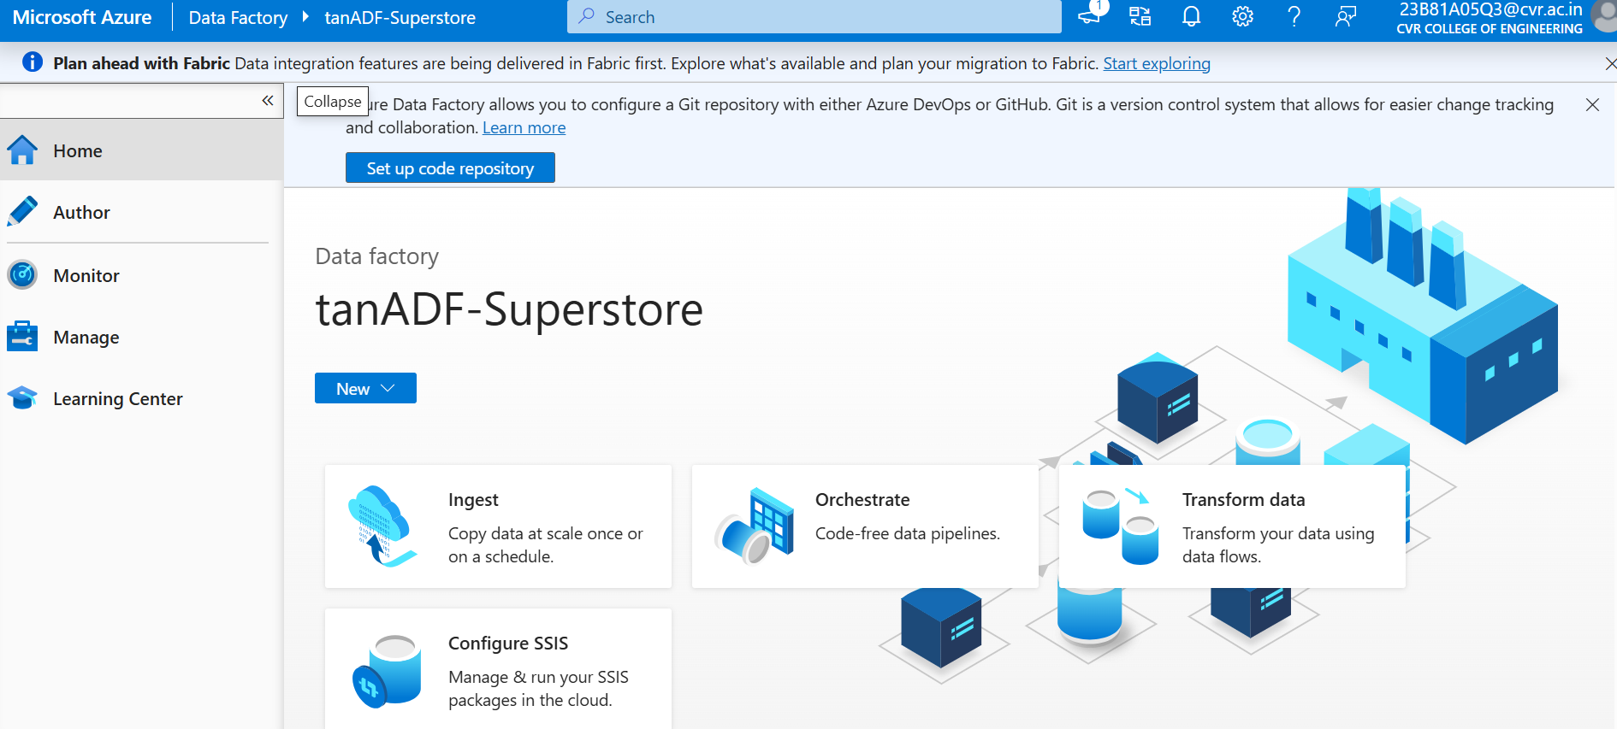
Step 7: Linked Service Configuration
A Linked Service was created to establish a connection between Azure Data Factory and Azure Blob Storage. This connection enables ADF to access files stored in the Storage Account.
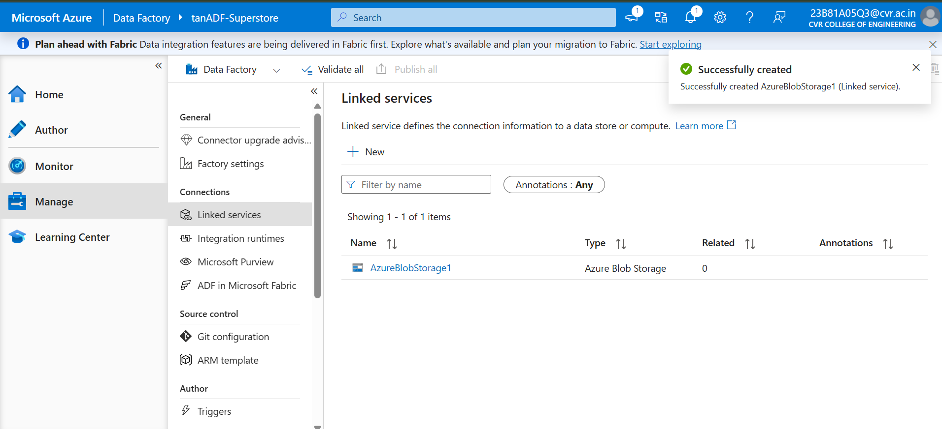

Step 8: Dataset Creation
Two datasets were created:
- Source Dataset (DS_Source) – points to the Superstore CSV file in the source container.
- Destination Dataset (DS_Destination) – points to the destination container where the copied file will be stored.
Datasets define the structure and location of data used in the pipeline.
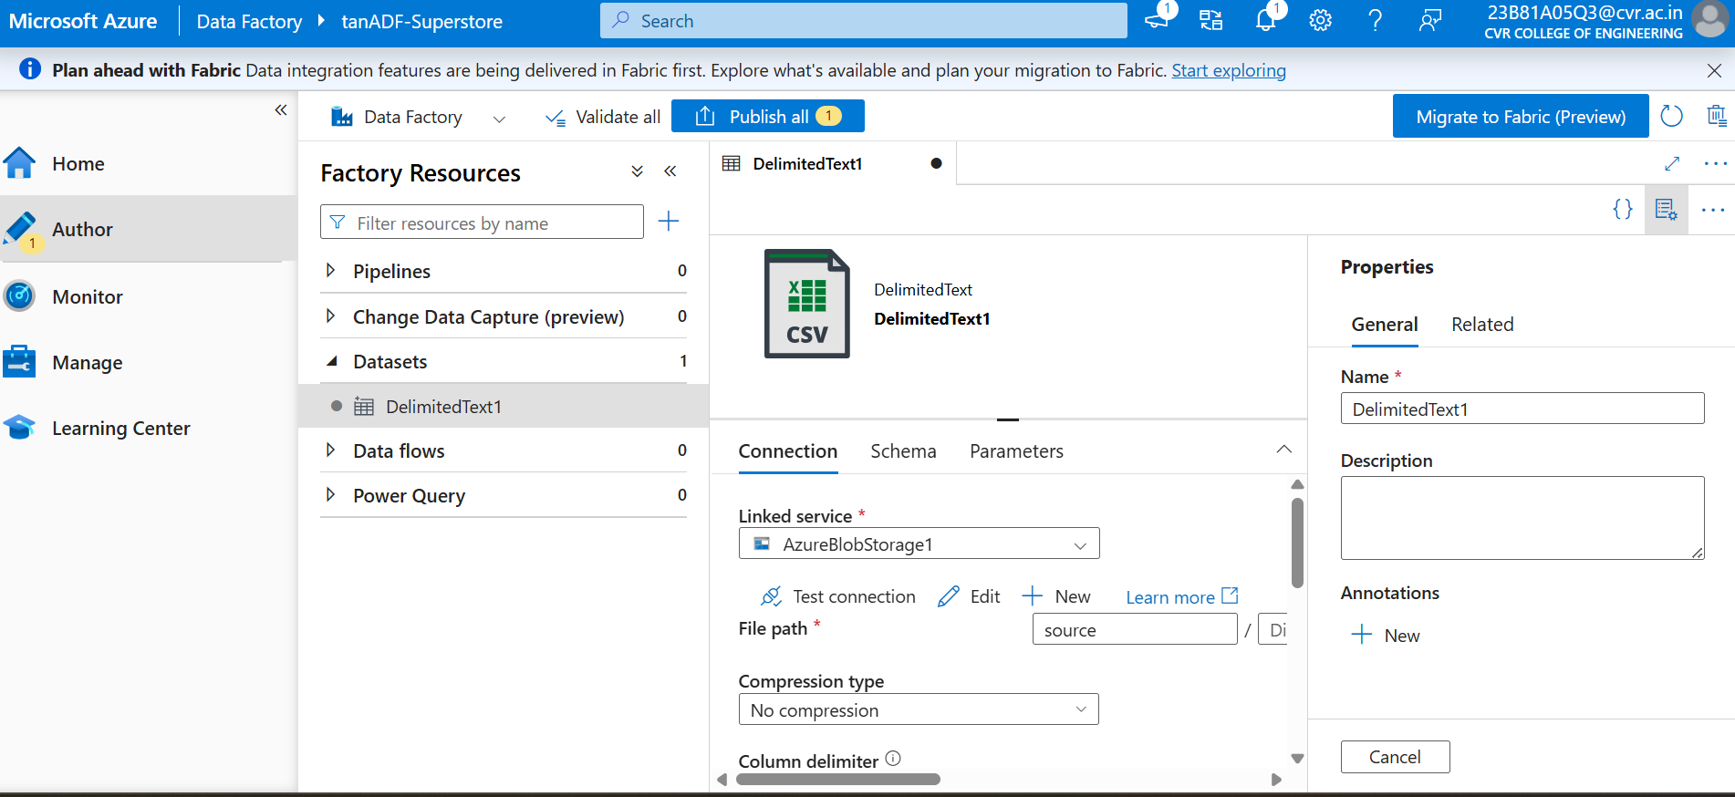

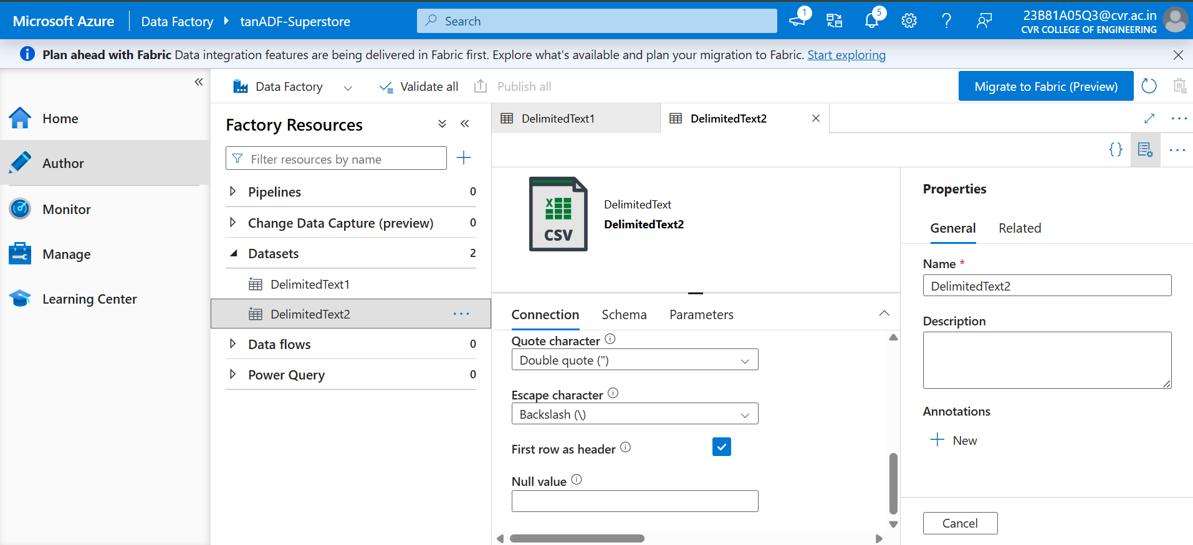

Step 9: Get Metadata Activity
A Get Metadata activity was added to the pipeline to retrieve file information such as:
- File existence
- File size
- Last modified date
This step validates the source file before data movement begins.
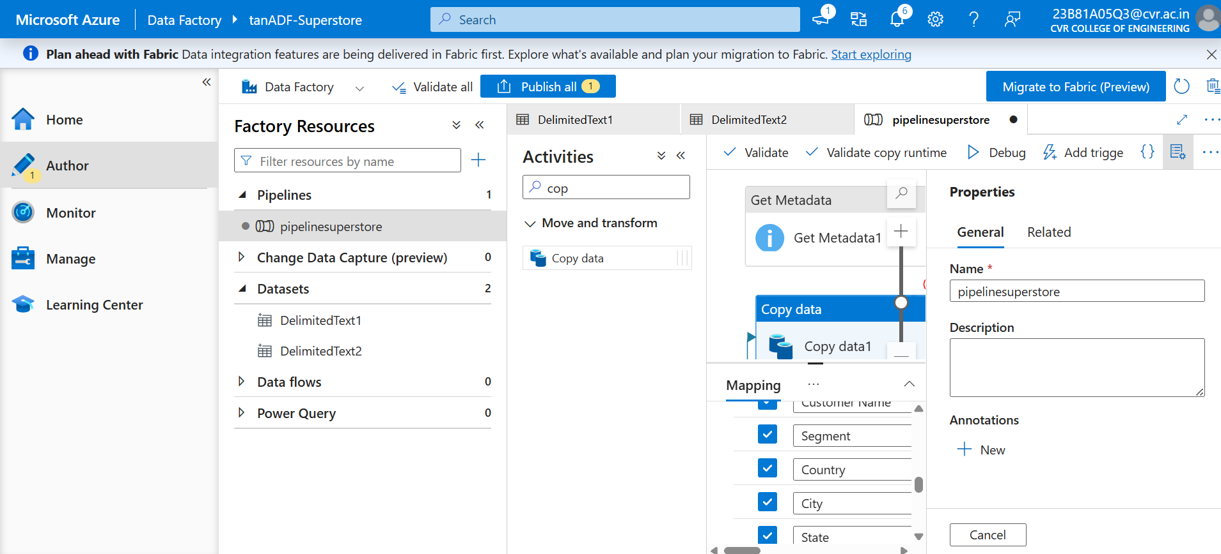
Step 10: Copy Data Activity
A Copy Data activity was configured to copy the CSV file from the source container to the destination container. Source and sink datasets were connected, and schema mapping was configured
Step 11: IAM Role Assignment
Required permissions were assigned through Azure IAM:
- Reader
- Storage Blob Data Contributor
These roles were granted to the Azure Data Factory managed identity, allowing it to access and copy data from Blob Storage securely.
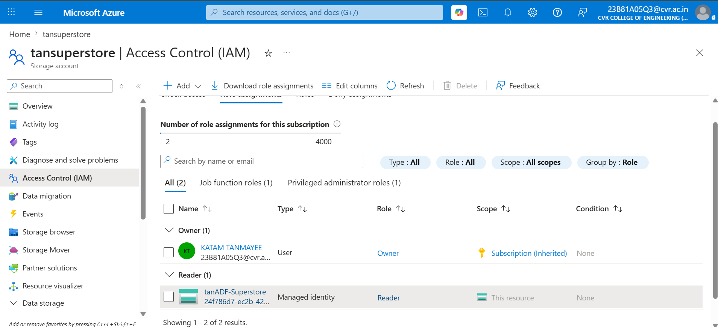

Step 12: Pipeline Execution
The pipeline was executed using the Debug and Trigger Now options in Azure Data Factory. The execution process validated metadata and copied the dataset to the destination location.
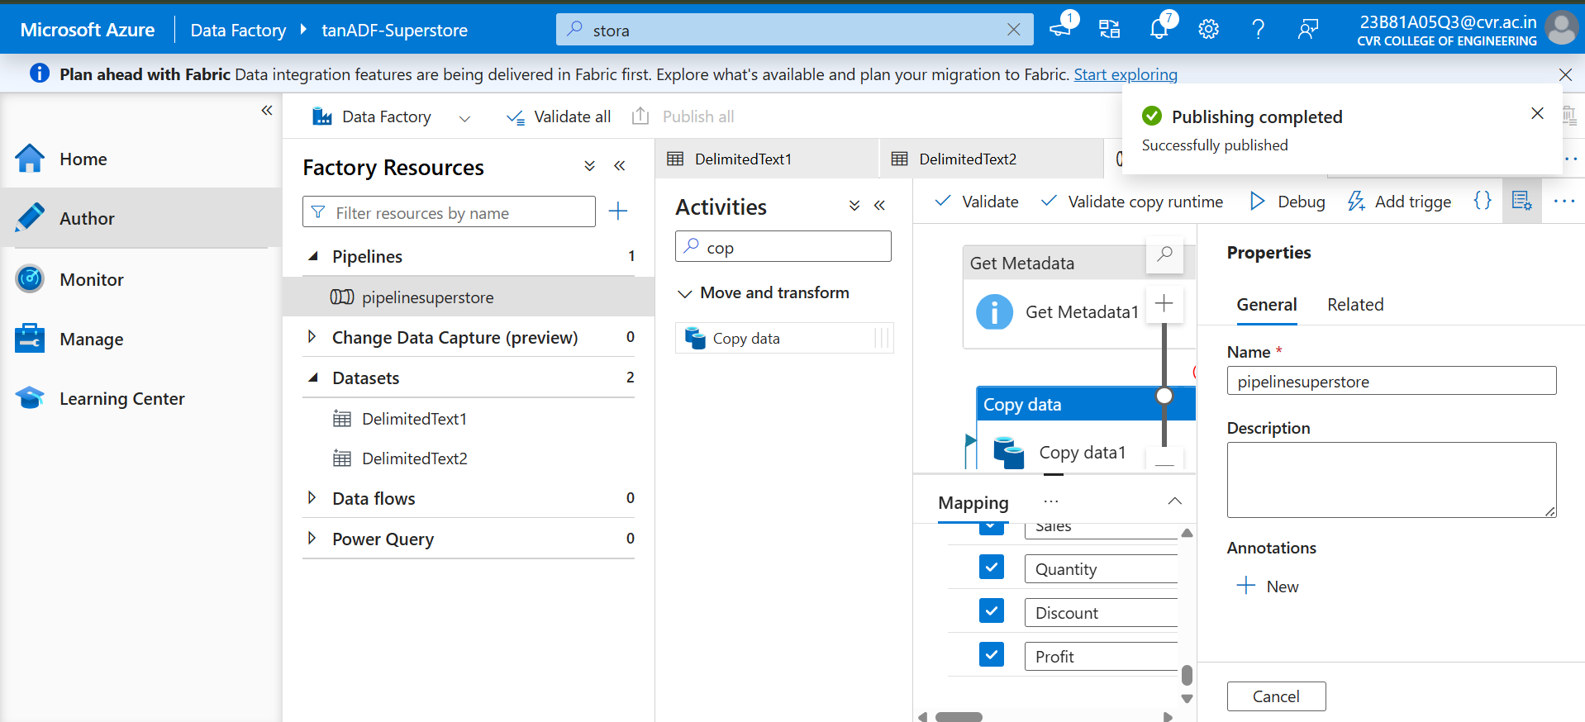

Step 13: Pipeline Monitoring
The pipeline run was monitored in the Monitor section of ADF. Execution details such as status, duration, rows processed, and activity logs were reviewed to confirm successful completion.
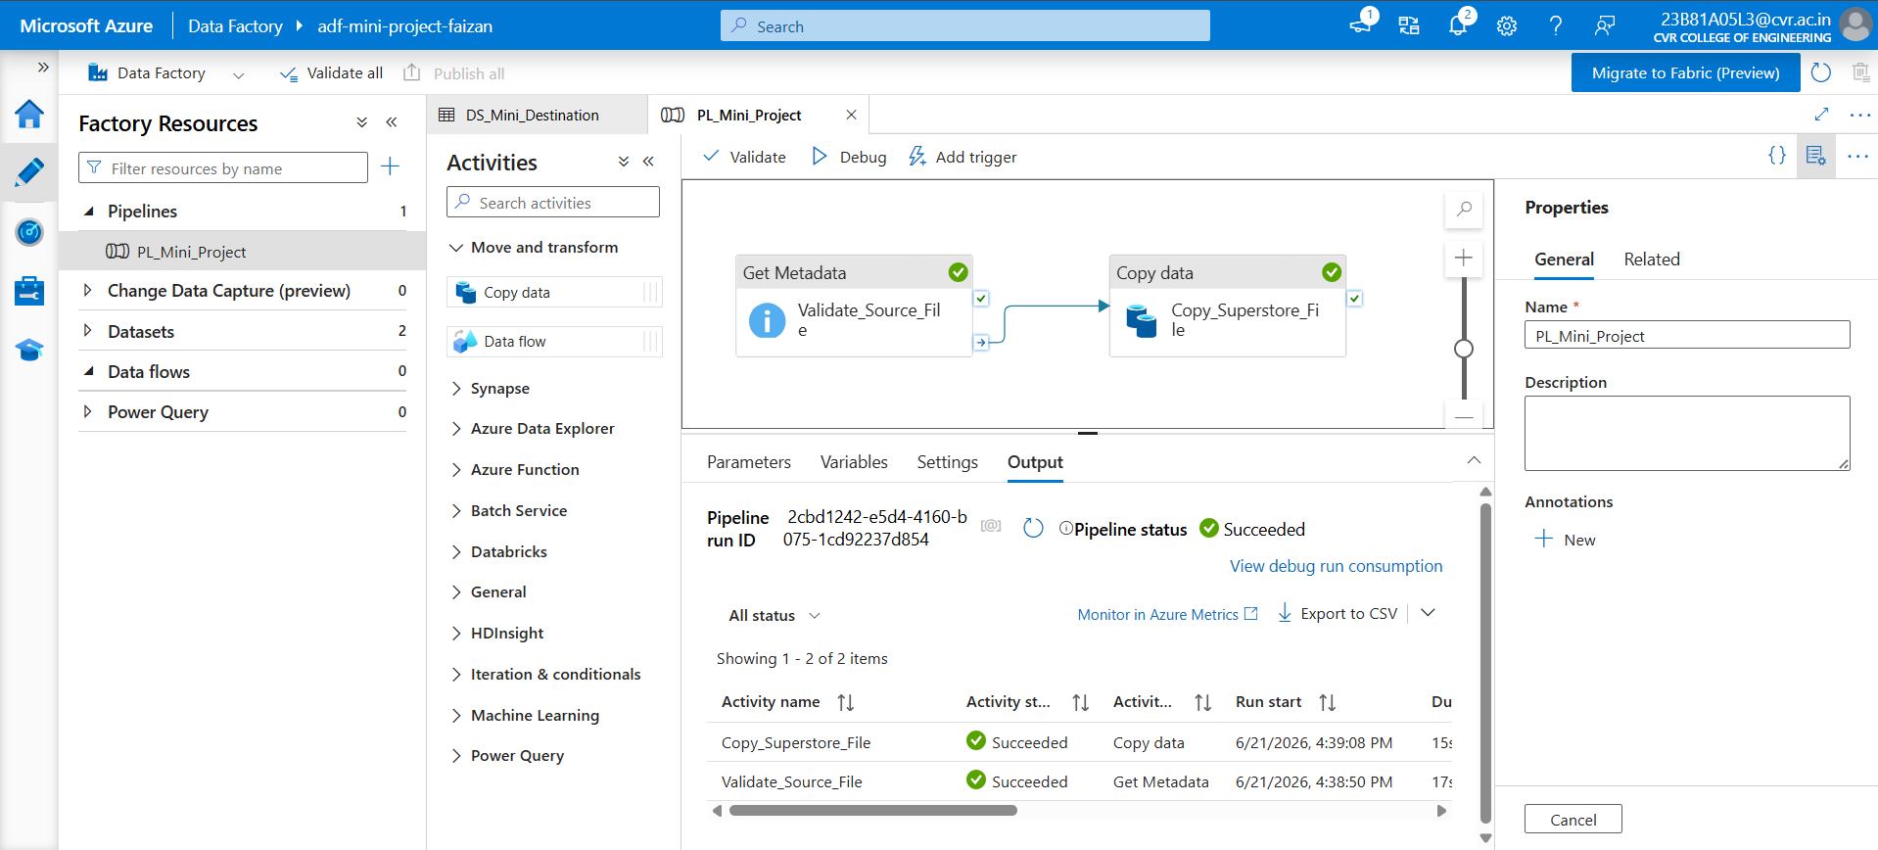
Step 14: Output Validation
The destination container was checked after execution. The copied CSV file was successfully available in the destination-data container, confirming that the pipeline worked correctly.

